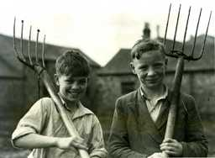 | A Child’s War |  |  |  |  |  | 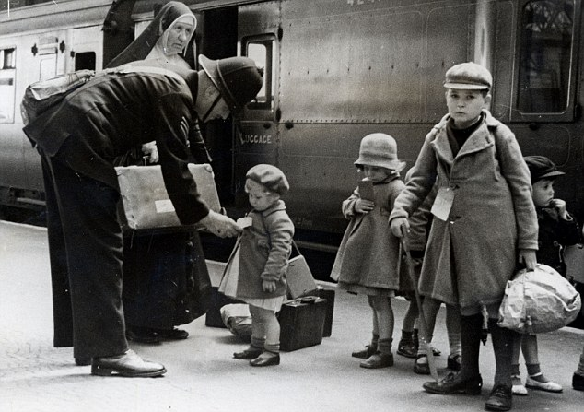
 | This curriculum map provides an overview of what your child will be learning across the curriculum this half term. Learning will be linked to our topic: A Child’s War.
… as readers, we will be studying the text ‘Rose Blanche’ and considering how the experiences of the War for a child in a different country differed to those of a child in Britain.  As writers we will be writing in a variety of text types in role as children during the War. |  | ...as historians, we will learn about life during World War 2 as a child. We will also focus on events such as evacuation, the Blitz and the Battle of Britain. |  |  |  | …as mathematicians, we will be continuing in our groups: looking at various number problems, shape, space and measure.
 |  | …in R.E. we will be thinking about the question: How do beliefs shape identity for Muslims? |  | …in P.E. we will be focusing on athletics and dodgeball.
…in Computing we will be exploring how we manage online information safely. | …as geographers, we will describe patterns of human population growth and movement, economic activities and land use, within the context of 1940’s Norfolk. |  | …in French we will focus on the unit ‘Le weekend’. |  | …as designers we will learn about rationing during the War and use this to create a 1940’s meal. |  | …as scientists we will explore how living things are classified into different groups. We will create our own classifications, giving reasons based on specific characteristics.

This curriculum map is correct at the time of going to print but is subject to change. If you have any questions about our curriculum please speak to your child’s class teacher.

