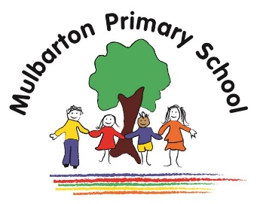

This is the knowledge organiser for our topic. It includes all the learning outcomes, key facts and vocabulary. Please share this with your child to help them develop their knowledge and understanding of our topic.

Title of topic: Road Trip USA

Topic Focus: Geography

Year 4 – Summer Term 1st Half

Topic focus:

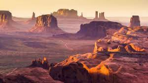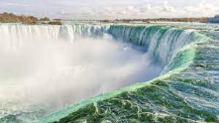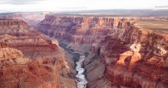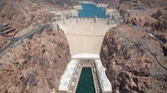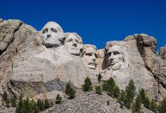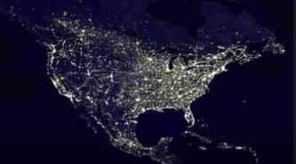

**Pop Art** is a famous modern American art form which started in **New York**.

Key Figures include Andy **Warhol**, Roy **Lichtenstein** and Piet **Mondrian**

**Key physical features:**

Grand Canyon

Niagara Falls

Monument Valley

Old Faithful geyser

**Key Human Features:**

Statue of Liberty

New York City

Golden Gate Bridge

Hoover Dam

Mount Rushmore

The United States of America is made up of 50 states.

The capital city is **Washington DC**

The **USA** has a wide range of **environments** and a diverse population, including **native Americans** (the indigenous people).

**Key vocabulary:**

Capital – town or city where the government of a country is based.

Climate - typical weather for an area, region or country.

Indigenous – occurring naturally or originating in a particular place.

Landmark – A landscape feature that is easily seen and recognised from a distance.

Native American – A member of one of the groups of people who were living in America before the Europeans arrived.

Physical features – An item on a landscape that has occurred naturally.

State – A part of a large country that has its own government.

Tribe – A group of people who live together and share beliefs, customs and language.

President – A person who has the highest position in a country that does not have a King or Queen.

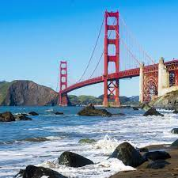

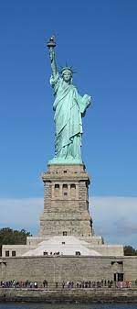

Modern American life is dependent   
on **electricity**.

Electrical circuits rely on **cells,  
switches, insulators, conductors**

