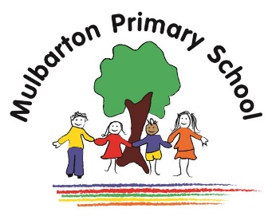

Title of topic: **Sunshine and Sunflowers**

Other possible themes: Spring/Summer, Planting, Gardening, Life cycles

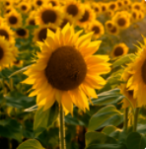

This is the knowledge organiser for our topic. It includes some key facts and vocabulary about our topic. Please share this with your child to help them develop their knowledge and understanding of our topic.

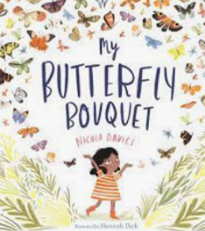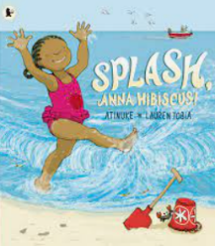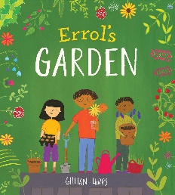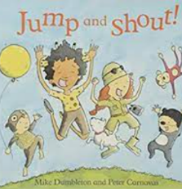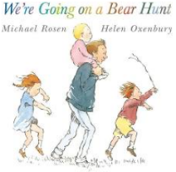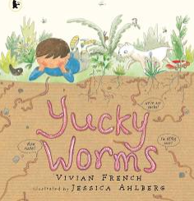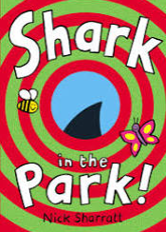

**Books we will use:**

**Experiences / WOW events:**

* Gardening / Reading Café
* Caterpillar –> Butterfly

**Key vocabulary:**

 seed

stem, leaf,   
petal, root

grow

bouquet

egg

wings, legs,   
tongue, antennae

insect

chrysalis

picnic

sun cream

hydrated

map

**Key facts / Knowledge:**

* A habitat is a place where living things live. Habitats include woodland, garden, ponds, deserts, and the Arctic.
* Plants and trees are living things.
* Parts of a plants and trees include the roots, stem, leaves, trunk, branch, flowers and petals.
* Plants need air, sunlight, warmth, water and nutrients from soil to grow.
* Flowers are brightly coloured to attract insects.
* Living things change over time.
* Female butterflies lay eggs on plants. Caterpillars hatch from the eggs. Caterpillars eat until they are fully grown, then they become a chrysalis. A butterfly emerges from a chrysalis.
* Butterflies, ladybirds and bees are insects.
* Insects are small animals that have six legs and a hard outer shell. Some insects have wings.
* The weather can change throughout the day, week and month. The weather is different at different times in the year.
* It is important to wear sun cream, sun hats and drink plenty of water to keep hydrated on hot days.
* Wearing sunscreen, a hat and sunglasses can protect the skin and eyes from sun damage.
* A map is a picture or drawing of an area.

Reception – Summer Term 1