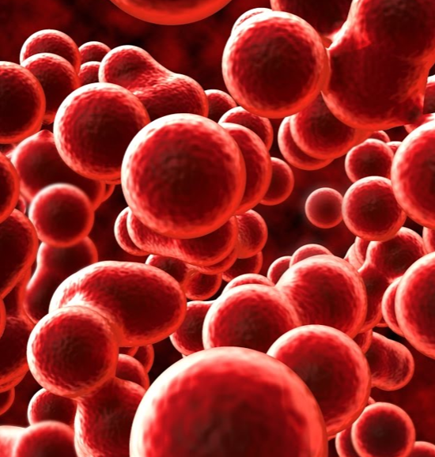 | Blood Heart |  |  |  |  |  | 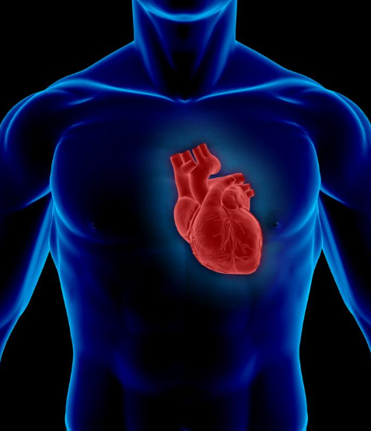
 | This curriculum map provides an overview of what your child will be learning across the curriculum this half term.
As readers we will engage with the novel Clockwork, taking part in a variety of activities to support our understanding of the text.  As writers we will be  writing diary entries, newspapers, balanced arguments and a story. |  | As historians we will be learning about the work of Dr William Harvey and Charles Drew. |  |  |  | As mathematicians, we will continue to be in groups, revisiting to secure and improve our understanding of a variety of topics, such as number, calculation and shape.
 |  | In R.E. we will focusing on what it means to be human. |  | As artists we will be creating sculptures of the heart and abstract artwork.
In computing we will continue to develop our understanding of the importance of being safe online. | In D.T., we will be exploring foods that keep our heart ‘happy’ and healthy. |  | As scientists we will learn about the circulatory system. |  | In P.E. we will be focusing on Gymnastics and OAA. |  | In French we will be continuing our topic, A l’ecole.

This curriculum map is correct at the time of going to print but is subject to change. If you have any questions about our curriculum, please speak to your child’s class teacher.

