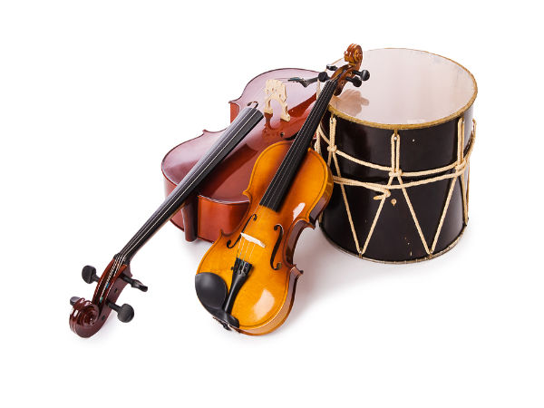 |  | Playlist |  |  |  | 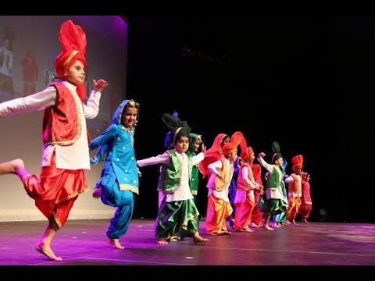
 |  | This curriculum map provides an overview of what your child will be learning across the curriculum this half term. Wherever possible learning will be linked to our focus topic.
As writers we will develop skills in writing poetry, rhyme, rhythm and use of figurative language. We will be recapping on use of apostrophes, possessive pronouns, sentence structures and other grammar. We will also write instructions. As readers we will study The Mousehole Cat by Antonia Barber. We will focus on the author’s use of figurative language, on inference skills and enjoyment of texts. |  | As scientists we will investigate how sounds are made, exploring vibrations pitch and volume. |  | As geographers, we will be using maps to build knowledge of the wider world, learning about different styles of music and where in the world they originate from. |  | As mathematicians we will be  developing our understanding of  fractions, including equivalent fractions, adding and subtracting fractions, and fractions that are more than 1 whole one.
 |  | As musicians we will compose our own digital music. |  | In art and design we will be responding to different types of music in art.  .
In design and technology, we will create our own musical instruments. | In French we will continue learning about As Tu Un Animal. | In PE lessons we will focus of gymnastics and outdoor activity this half term. | In RE, we will continue to consider the important question: what is truth? |  | In learning for life we will be learning about eating healthily and health and fitness. | Every Thursday  we have activities: enrichment activities,  Forest Schools,  P.E.

This curriculum map is correct at the time of going to print but is subject to change. If you have any questions about our curriculum please speak to your child’s class teacher.

