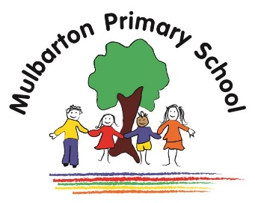

Year 2-Spring 1

**Key facts**

A community can change over time. In the past, people shopped at smaller shops such as a grocer, bakery and butcher shop. Now, lots of people do their shopping online or at a supermarket.

**Key facts**

It is important to look after our environment. Removing litter and planting new bulbs makes the community nicer.

**Title of topic:** Street Detectives

**Topic focus**: History and Geography

**Key facts**

The human features of a settlement can be made from natural and man-made materials.

Natural materials are dug out of the ground, grown or taken from a living thing.

**Key facts**

The United Kingdom is made up of 4 countries each country has a capital city.

**Key facts**

Animals, including humans have offspring that grow into an adult.

**Key facts**

Maps include symbols, instead of words. They could be pictures or letters. A key explains what the map symbols mean.

A map is a picture or drawing that shows the location of human and physical features.

Maps use compass directions; North, South, East and West.



**Key vocabulary:**

Chronological timeline

Century

Community

Decade

Feature

Industry

Key

Litter

Route

Property

Settlement

Symbol

Lifecycle

Offspring

Growth

Habitat

This is the knowledge organiser for our topic. It includes all the learning outcomes, key facts and vocabulary. Please share this with your child to help them develop their knowledge and understanding of our topic.

**Key facts**

Communities are made up of the people who live there. All people have similarities and differences but are equally important.

