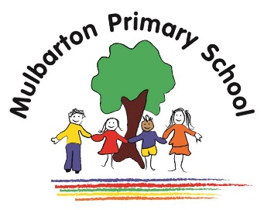

Title of topic: Once Upon a Time

Other possible themes: Shrove Tuesday, Easter, other fairy tales or traditional tales

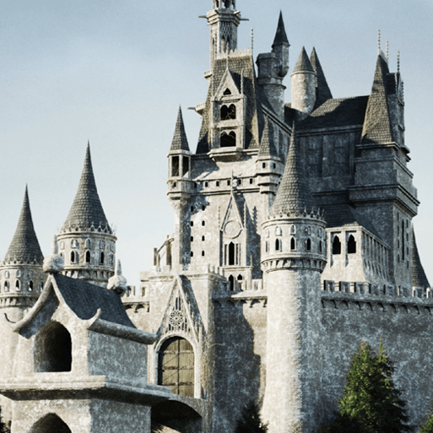

This is the knowledge organiser for our topic. It includes some key facts and vocabulary about our topic. Please share this with your child to help them develop their knowledge and understanding of our topic.

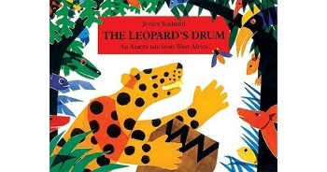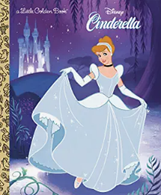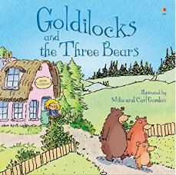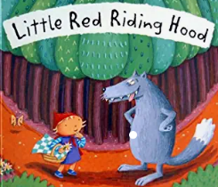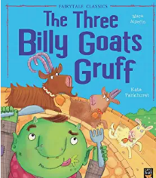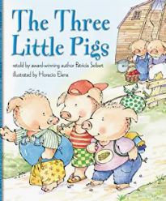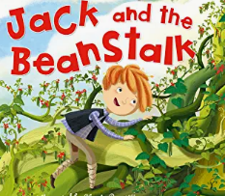

**Books we will use:**

Various versions of:

**Experiences / WOW events:**

* Gressenhall Trip
* Pancake Day
* Maths Morning

**Key vocabulary:**

 once upon a time

traditional tale

fairy tale

character

setting

past

changes

similar / different

royal

king

queen

United Kingdom

**Key facts / Knowledge:**

* Traditional tales are stories that have been told to children for hundreds of years.
* Many traditional tales are set in woodlands and forests and often include animals as main characters.
* Fairy tales are fantasy stories with imaginary beings and magical settings.
* Many fairy tales are set in castles and often include royal characters like kings or princesses.
* These type of stories are often set in the past.
* Stories, books and pictures are used to help people find out about events in the past and people who lived in the past.
* The way that people lived in the past is not the same as the way that we live now. There have been changes to schools, play activities, toys, food, transport and clothes
* Objects from the past can look different to objects now.
* Identifying similarities and differences helps us to make comparisons between our life and life in the past.
* Kings, queens, princes and princesses are part of royal families.
* The United Kingdom has a royal family.
* Elizabeth II is the Queen of the United Kingdom.

Reception – Spring Term 2