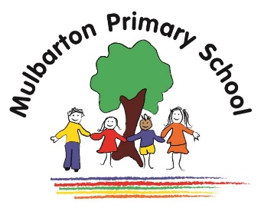

Title of topic: Starry Night

Other possible themes: Winter Wonderland, Chinese new year

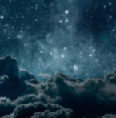

This is the knowledge organiser for our topic. It includes some key facts and vocabulary about our topic. Please share this with your child to help them develop their knowledge and understanding of our topic.

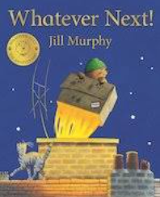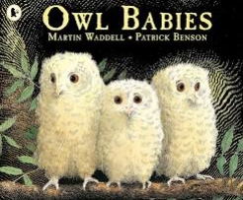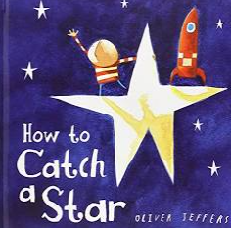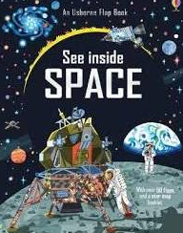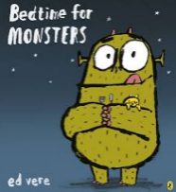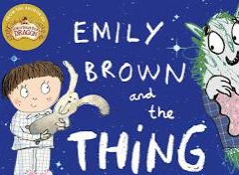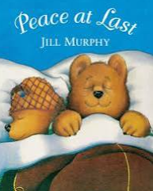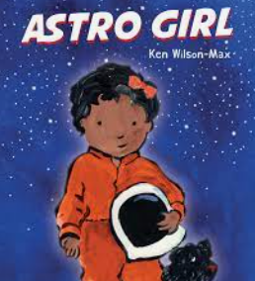

**Books we will use:**

**Experiences / WOW events:**

* Sleep cafe
* Chinese New Year – Year of the Tiger

**Key vocabulary:**

environment

day / night

light / dark

nocturnal / diurnal

Moon

Sun

Earth

stars

planet

orbit

sleep health

shadow

**Key facts / Knowledge:**

* The environment changes through the day and the year.
* The Moon moves around (orbits) the Earth.
* The shape of the Moon changes each day.
* The stars and Moon are always in the sky but the Sun's bright light hides them in the daytime.
* People have visited the Moon.
* People travel into space in space shuttles.
* Darkness is caused by the absence of light.
* It is dark at night because that part of Earth is facing away from the Sun.
* During the day, it Is light because that part of Earth is facing towards the Sun.
* Nocturnal animals are awake during the night and asleep during the day. Owls and bats are nocturnal.
* Nocturnal animals have special features that help them in the dark, such as excellent hearing or sense of smell.
* Diurnal animals are awake in the day and sleep at night time. Humans are diurnal animals.
* Sleep is important for human health.
* While we sleep, some people work.
* Brushing teeth twice daily and avoiding sugary drinks and snacks help keeps teeth healthy.

Reception – Autumn Term 1