

This is the knowledge organiser for our topic. It includes all the learning outcomes, key facts and vocabulary. Please share this with your child to help them develop their knowledge and understanding of our topic.

**Year 4 – Spring 2nd half**Title of topic:: **Playlist**Topic Focus:: **Music and Science of sound.**

Topic focus:

**Singing**Singing is making musical sounds with the voice. It is part of every culture in the world.  
There are lots of different types of singing, including:  
- Pop  
- Jazz  
- Opera  
- Country

**Sound**

Sounds are how we communicate, from babies crying for attention to children and adults talking. Sounds are made when an object vibrates. The vibration travels through the air as sound waves until they reach our ears. Sounds are made by living things, such as animals and people, and objects, such as musical instruments.

**Musical Instruments**Musical instruments are grouped according to how they make a sound.   
 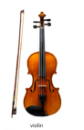 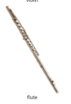 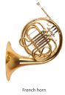 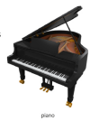

String Woodwind Brass Keyboard

**The Human Ear**

The ear is an organ that allows us to hear. The pinna is the only part of the ear that is outside the head and it has a special shape to funnel sound into the ear canal.

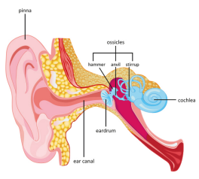

Key vocabulary:

acoustic - an instrument that is not made louder by electrical equipment.  
beat - the steady pulse that you feel in a piece of music.  
cochlea - a hollow coiled tube inside the inner ear, which contains nerves that help to carry information about sound to the brain.  
decibel (db) - unit for measuring the loudness of sound.  
duet - a performance by two singers or musicians.  
ear canal - tube that connects the outer and middle ear.  
eardrum - the thin membrane that separates the outer and middle ear and vibrates in response to sound waves.  
ensemble - a group of musicians who perform together.  
instrument - a device used to make music.  
melody - the main tune in a piece of music.  
ossicles - three small bones in the middle ear.  
percussion - a group of musical instruments that are played by striking them with an object or your hands, such as drums, tambourines and cymbals.  
pinna - the visible part of the outer ear .  
pitch - the measure of how high or low a note is.  
soundproof - designed to prevent the passage of sound.  
tempo - the speed of a piece of music.  
vibration - a quick, back and forth movement.

In the past, people believed many strange things about the treatment of disease and illness. People did not know about germs and believed that illness could be spread by smells.

Operations were nearly always carried out without anaesthetics until the 19th Century. Since then, many different anaesthetics have been invented and discovered.