

Title of topic

Peasants, Princes and Pestilence

Topic focus: Medieval

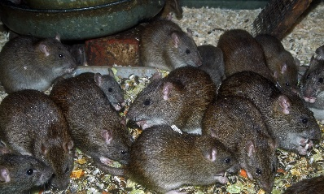

Know the similarities and differences between bacteria and fungi.

In 1348 the Black Death hit England. Eventually, people realised that it was spread by fleas that were on rats.

The peasants revolt in 1381 was a result of the poll tax.

A key figure was Wat Tyler

The ways in which the diets of medieval paupers and princes affected their health and well-being.

That the Black Death originated in Asia and then spread through Europe.

Key vocabulary:

black death

pestilence

bacteria

Canterbury Tales

contaminate

chivalry

heraldry

Flagellants

infection

jousting

knight

medieval

monastery

Middle Ages

banquet

symptom

timeline

This is the knowledge organiser for our topic. It includes all the learning outcomes, key facts and vocabulary. Please share this with your child to help them develop their knowledge and understanding of our topic.

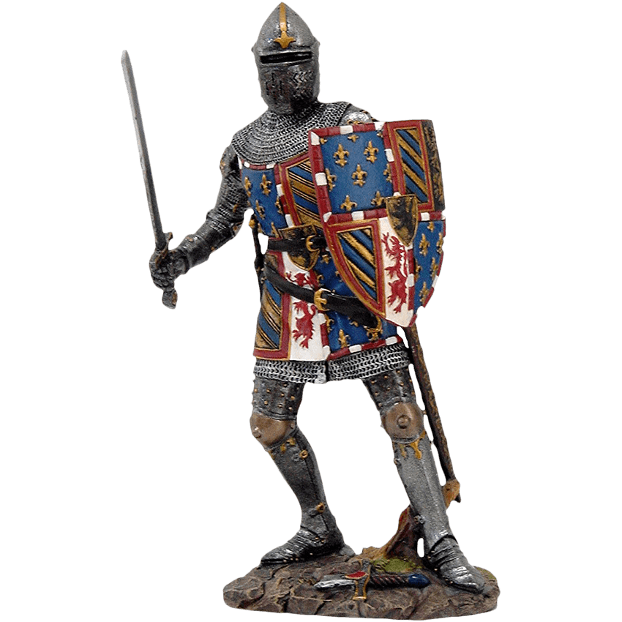

Year 5 Spring 2