Peasants, Princes and Pestilence  Spring Term (2nd half)  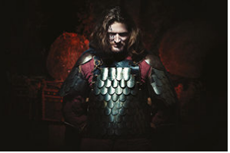  This curriculum newsletter provides an overview of your child’s learning in year 5 this half term. In this wonderful History topic we shall be travelling to the Medieval Period to find out about gruesome topics such as the Black Death! |  | English  In English the children will be reading Fire, Bed and Bone - a wonderful narrative told from the point of view of a dog.  In our Punctuation and Grammar we will be continuing to work on creating sentences with different structures, cohesion within paragraphs and using brackets, dashes and commas for parenthesis. |  | Maths  In Maths the children will be continuing to work on fractions and extend onto decimals and percentages. Marvellous Maths will continue to focus on the recall of time-tables facts and other mental maths skills in a fun and active way.
PE  In PE the children will be completing a unit on gymnastics. | Art & Design  In Design technology the children will be creating their recipe for Pottage, a medieval soup. |  | Computing  In Computing we will be developing their understanding of computer systems and how information is transferred between systems and devices, |  | Science  In Science we will learning about animals including humans, focussing on human changes from birth to old age, puberty reproduction and personal hygiene.
Music  In Music we will continue to learn about Motown music and play along to Dancing in the Street with musical instruments | Humanities  In History the children will consider the Black Death and the peasant’s revolt during the Medieval period. |  | PHSE / RE  What can we learn about the world/knowledge/ meaning of life from the great Buddhist/Christian philosophers?  In PHSE we will learn about changes during puberty and consider gender identity. |  | Languages  In French the children will continue learning about the weather.

