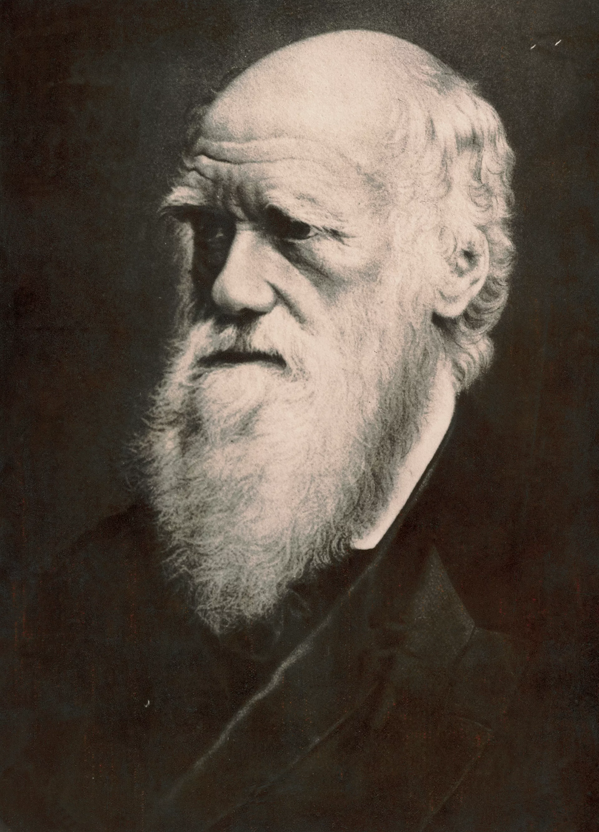 | Darwin’s Delights |  |  |  |  |  | 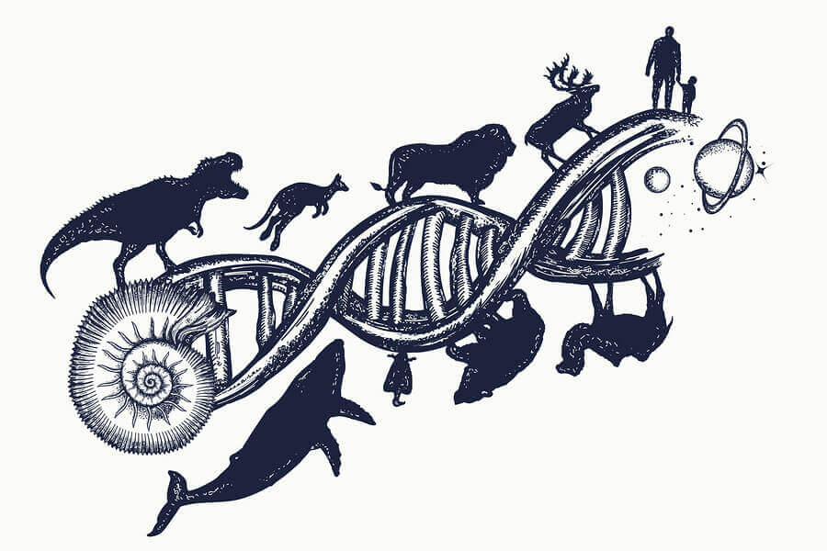
 | This curriculum map provides an overview of what your child will be learning across the curriculum this half term. Learning will be linked to our focus topic: Darwin’s Delights, as well as our science topic: inheritance and evolution. We will...
… as readers, we will engage with the Greek tale The Adventures of Odysseus, taking part in a variety of activities to support comprehension.  As writers we will be  developing our informal and formal writing, improving our skills in pieces such as reports. |  | ...investigate the life and work of Charles Darwin. We will find out about his travels, his observations of plant and animal life and how he learnt from fossils.  We’ll also find out about people associated with Darwin: Mary Anning and Alfred Wallace. |  |  |  | …as mathematicians, we will be studying the relationships between fractions, decimals and percentages.  We will then be recapping previously learnt knowledge and converting between different units of measure.
 |  | …in R.E. we will be thinking about the question: How do Buddhists explain suffering in the world? |  | …as artists we will be focusing on sketching and creating observational drawings.
…in Computing we will be using computer programs to make 3D models | …as geographers, we will be exploring climate zone and biomes. We will also find out what the Galapagos Islands are like and make comparisons between this and the UK. |  | …as scientists we will learn about inheritance, adaptation and evolution. We’ll discover how Darwin’s observations have changed science and how DNA determines who we are. |  | …in P.E. we will be developing our skills in dance and improving our stretching and flexibility. |  | …in French we will be continuing learning the vocabulary of ‘l’ecole’.

This curriculum map is correct at the time of going to print but is subject to change. If you have any questions about our curriculum please speak to your child’s class teacher.

