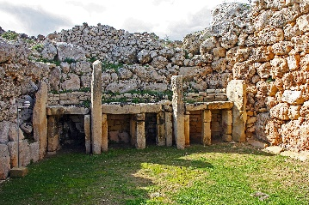  This curriculum map provides an overview of what your child is learning in Year 3 this half term. This half term our topic is Tremors.  Tremors |  | Maths  As mathematicians, the children will consolidate their knowledge of addition and subtraction and will then continue to develop knowledge of multiplication and division learning to multiply 2- digit and 1-digit numbers. In division we will dividing 2-digit by 1-digit and scaling numbers up and down. We will also look at money and different ways of representing data.  Marvellous Maths will focus on recall of number facts and other mental maths skills in a fun and active way. Children will also be using their knowledge to solve reasoning problems. | Humanities  As Geographers we will be learning about volcanoes and earthquakes, locating volcanoes across the world. We will be learning about the history of the earth and using an ordnance survey map to add details such as paths. As Historians we will be learning about the Stone Age and looking at ways they have influenced our lives today.
Science  As scientists we will be learning about different types of rocks and classifying them. We will learn about the formation of fossils and when fossils were created. As scientists, we will also be learning about the different properties of soil. | English  As writers, we will research inventions from the past and do some information writing on these. We will also create postcards too. We will create our own comic strips based on ‘Ug Stone Age Boy’ as well as persuading others to buy our stone age houses. | Art/DT  As artists we will be learning about the artist Richard Long and creating our own artwork in his style. We will create woven pictures and patterns using natural and manmade materials. We will also create our own volcano models. | French  As linguists we will be learning French animals.
Learning for Life/RE  In learning for life lessons, the children will be continuing to follow the PATHS/RSE scheme. We will be looking at how we control our emotions.  In RE, we will be continuing to learn about “The Holy Trinity” and will move onto making moral decisions. | PE  As sportspeople, the children will begin dance lessons and will focus on stretching and flexibility. | Computing  In computing, the children will continue to learn about computer systems and networks. We will also be moving onto animations. |  | Music  As musicians we will be continuing to learn the ukulele. We will also follow the Charanga units too.

