Stargazers  Spring term 2022 (1st half)  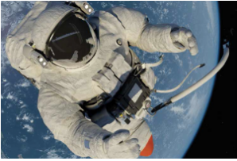  This curriculum newsletter provides an overview of your child’s learning in year 5 this half term. In this amazing Science topic, we shall be travelling through space to discover and investigate different celestial bodies. |  | English  In English the children will be reading Cosmic by Frank Cottrell-Boyce, a humorous modern day space travelling adventure story.  In our Punctuation and Grammar we will be continuing to work on creating cohesion within paragraphs and using brackets, dashes and commas for parenthesis. We will be securing our understanding of word classes and modal verbs. |  | Maths  In Maths we will be focussing on perimeter and area and, following that, we will be broadening and deepening our knowledge and understanding of multiplication and division and starting to look at fractions, decimals and percentages.  Marvellous Maths will continue to focus on the recall of times tables facts and other mental maths skills in a fun and active way, including using Times Table Rockstars.
PE  In PE the children will be enjoying dance and gymnastics. | Art & Design  In DT we will be exploring ways to control devices using programming. |  | Computing  In Computing we will be using computer- controlled devices. |  | Science  In Science we will be learning about the sun, moon and the planets in our solar system. We will be investigating how they move and how that affects day and night, as well as explore gravity.
Music  In Music we will be maintaining melodic lines and developing control in 2- and 3-part harmonies. | Humanities  The children will be exploring the validity of a range of historical reports and focus on organising and articulating information. |  | PHSE / RE  In RE we will be looking at the impact of beliefs on music and art.  In PHSE we will explore respectful relationships. |  | Languages  In French the children will be launching into a topic on weather.

