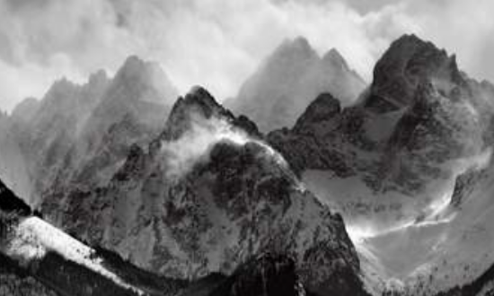 |  | Misty Mountain Sierra!  This curriculum map provides an overview of what your child will be learning across the curriculum this half term. Wherever possible learning will be linked to our focus topic. |  |  |  | 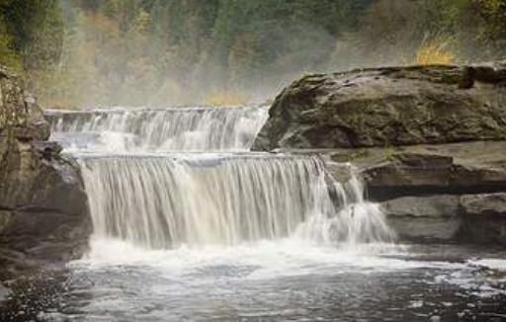
As readers, we will be reading a picture book based in an Icelandic town involving mythical beings, and an unlikely hero who embarks on a quest.  As writers, we will be learning to use and recognise a variety of conjunctions, adverbs, propositions and adverbials. We will be learning to write persuasively and be practising using punctuation we have learnt so far this year. |  |  |  | As mathematicians we will be developing our understanding of  multiplication and division including problem solving and reasoning. As well as this we will be learning to calculate area of shape.
As scientists we will be working scientifically to find out about changing states of matter: observing boiling and melting of different substances. We will also be learning about the Water Cycle and climate change. |  |  | As geographers, we will be using maps to build knowledge of the wider world and the UK, exploring the points of the compass. We will be looking at rivers, valleys and mountains. |  | In RE, we will be thinking and learning about the questions ‘What we mean by truth?’ Is seeing believing?’. Through these questions we will look at several faiths, including Sikhism. |  | In Learning for Life we will be learning about families and people who care for us. We will also continue to look at how we can ensure we are being safe in our choices.
As musicians we will be learning about different note durations and musical rests. | In computing lessons, we will explore coding and computer programming using LOGO. |  | In PE lessons we will being taking part in dance and flexibility. |  | As artists will we be exploring and creating work in the style of Georgia O’Keefe. |  | Our topic in French is As Tu Un Animal. We will be learning how to talk about pets we have or would like to have.

