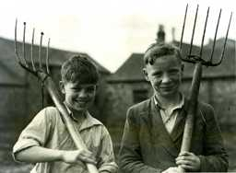 | A Child’s War |  |  |  |  | 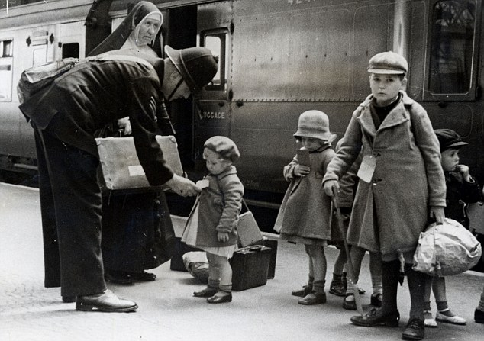
 | This curriculum map provides an overview of what your child will be learning across the curriculum this half term. Learning will be linked to our topic: A Child’s War.
… as readers, we will be studying the text ‘Rose Blanche’ and considering how the experiences of the War for a child in a different country differed to those of a child in Britain.  As writers we will be writing in a variety of text types in role as children during the War. |  | ...as historians, we will learn about life during World War 2 as a child. We will also focus on events such as evacuation, the Blitz and the Battle of Britain. |  |  | …as mathematicians, we will consider ratio, algebra, decimals and fractions
 |  | …in R.E. we will explore what it means to be humanist |  | …in P.E. we will be focusing on athletics and dodgeball
…in Computing we will be exploring 3D Modelling. We will explore internet safety through managing online information. | …as geographers, we will describe patterns of human population growth and movement, economic activities and land use, within the context of 1940’s Norfolk. |  | …as designers we will learning about Anderson Shelters and creating our own versions. |  |  | …as scientists we will explore humans and the circulatory system.

This curriculum map is correct at the time of going to print but is subject to change. If you have any questions about our curriculum please speak to your child’s class teacher.

